 | Slidematic Products Co.  4520 West Addison Street  Chicago, IL 60641  Website: www.slidematicproducts.com | Phone: 773.545.4213  Fax: 773.545.0797  Email: info@slidematicproducts.com

Custom Wire Form Services
From the most complex wire forms to the simplest, we have been specializing in the mass production of wire form products for over 65 years. Our production facility includes over 40 Multi-slide/Four-slide machines, which give us the capability to handle wire diameters as small as .004", up to a maximum of .187". Materials include, but are not limited to: aluminum, brass, galvanized, low carbon steel, nickel, various special alloys, and stainless steel.
We design, build, and maintain all tooling in-house. All tooling is designed utilizing the latest in CAD software employing standardized components whenever possible. Design procedures are structured to make full utilization of our CNC Machining Center and Wire EDM equipment. These techniques assure initial quality and consistent quality replacement components and/or duplicate tools, while serving to facilitate modifications when they are required due to part revision.
Our commitment to quality starts in the quotation process and runs all the way through the actual running of production. During the quotation process, all part designs are reviewed for potential control problems. Every attempt is made to identify and inform our customers of potential production concerns, and alternative part designs may be suggested to improve product quality or help lower costs. To ensure total quality during the production process, we employ the latest inspection techniques and equipment. Being ISO certified, these processes are documented, controlled, and audited on a consistent basis.

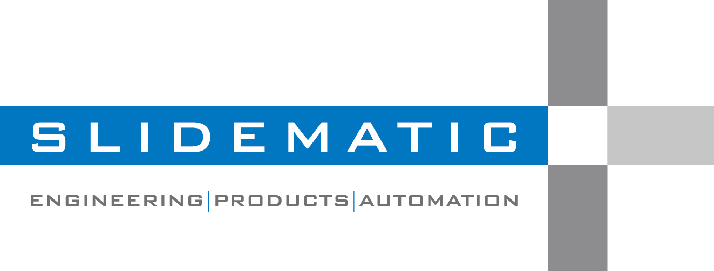

Custom Wire Form Capabilities:
Capabilities | Contract Manufacturing Easy to Complex parts Medium, and Large Production Volumes Miniature to Medium sized parts
Industry Focus | Agricultural Automotive Appliance Construction Electrical Electronics Furniture Medical Telecommunications
Intended Application | Circuit Breakers Seed Metering Systems Hardware Electrical Metering Hair Trimmers Insert Moldings Sensor Components Electronic Connectors Furniture Parts Fuse Clips
Industry Standards | ISO 9001:2015  International Organization for Standardization
Production Method | Four-slide Integrates the stamping and forming process Punch Press
Materials | Aluminum Brass Copper Galvanized Nickel Nickel Alloy Stainless Steel Steel
Stamping Features | Embossing/Coining Forming
Additional Services Provided | Assembly Consulting Deburring Design Heat Treating Packaging Plating Powder Coating Stress Relieving Swaging Trimming
File Formats | CAD File extensions: .dwg, .dxf, .stp, .igs, .dft, .par, .asm

